ASSIGNMENT - 3.1
NAME:AKSHARA JYOTHI VEERABATHINI
ROOL NO:2303A51793
BATCH:12
Lab Experiment: Prompt Engineering – Improving Prompts and Context Management (0.5 marks)
Objective
To explore how prompt design and context influence AI-generated outputs and to learn techniques to improve AI responses.

Tools Required
- GitHub Copilot / Google Gemini / ChatGPT
- VS Code / Google Colab
- Internet access
Procedure
- Select a simple task: "Write a Python function to check if a number is prime."
- Use different prompting strategies to generate the solution:
- Zero-Shot – no examples.
- One-Shot – one example provided.
- Few-Shot – multiple examples provided.
- Context-Managed – detailed prompt with constraints and instructions.
- Record AI responses and refine prompts to improve code quality.
- Request AI to optimize the logic for efficiency.
- Compare results and document improvements.
- Sample Prompts
- Zero-Shot:
Write a Python function to check if a number is prime.
PROMPT: #Write a Python function to check if a number is prime.
: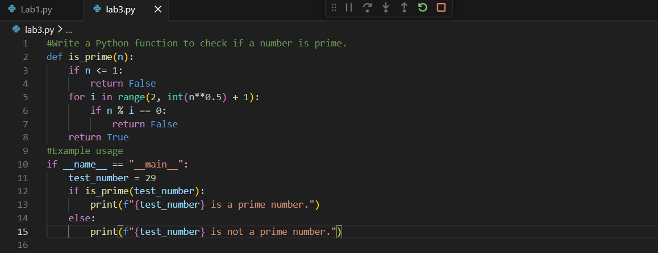
OUTPUT:
CODE:
def is_prime(num):
if num <= 1:
return False
for i in range(2, int(num**0.5) + 1):
if num % i == 0:
return False
return True
#Example usage
if __name__ == "__main__":
test_number = 29
if is_prime(test_number):
print(f"{test_number} is a prime number.")
else:
print(f"{test_number} is not a prime number.")
- One-Shot:
Example: Input: 5 → Output: Prime. Now, write a function to check if a number is prime.
PROMPT: #Write a python program to check whether a prime number or not taking input from user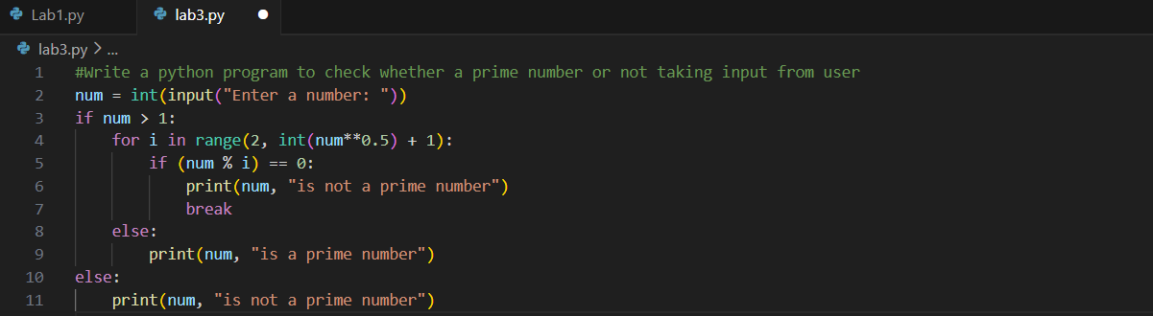
OUTPUT:
CODE:
if num > 1:
for i in range(2, int(num**0.5) + 1):
if (num % i) == 0:
print(num, "is not a prime number")
break
else:
print(num, "is a prime number")
else:
print(num, "is not a prime number")
- Few-Shot:
Example 1: Input: 7 → Output: Prime
Example 2: Input: 10 → Output: Not Prime
Example 3: Input: 2 → Output: Prime
Generate the function accordingly.
PROMPT: #Write a python program to check whether a prime number or not taking input from user 3 numbers.
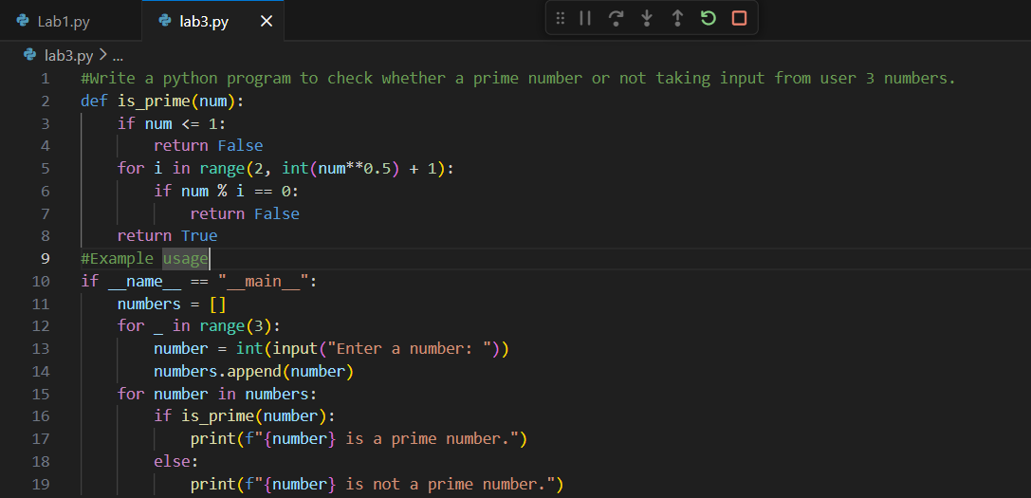
OUTPUT:
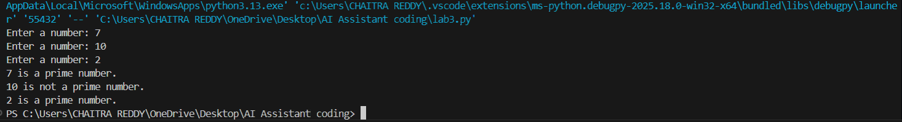
CODE:
def is_prime(num):
if num <= 1:
return False
for i in range(2, int(num**0.5) + 1):
if num % i == 0:
return False
return True
#Example usage
if __name__ == "__main__":
numbers = []
for _ in range(3):
number = int(input("Enter a number: "))
numbers.append(number)
for number in numbers:
if is_prime(number):
print(f"{number} is a prime number.")
else:
print(f"{number} is not a prime number.")
- Context-Managed (With Optimization)
PROMPT:
#Iam a experienced Python programmer.Write a Python program to check whether a given number is prime.The program must read the number using the input() function.
#The program must read the number using the input() function.
#Convert the input to an integer.
#Handle edge cases such as numbers less than or equal to 1.
#Use an optimized approach by checking divisibility only up to the square root of the number.
#Print Prime if the number is prime, otherwise print Not Prime.
#Ensure the code is efficient and well-structured.
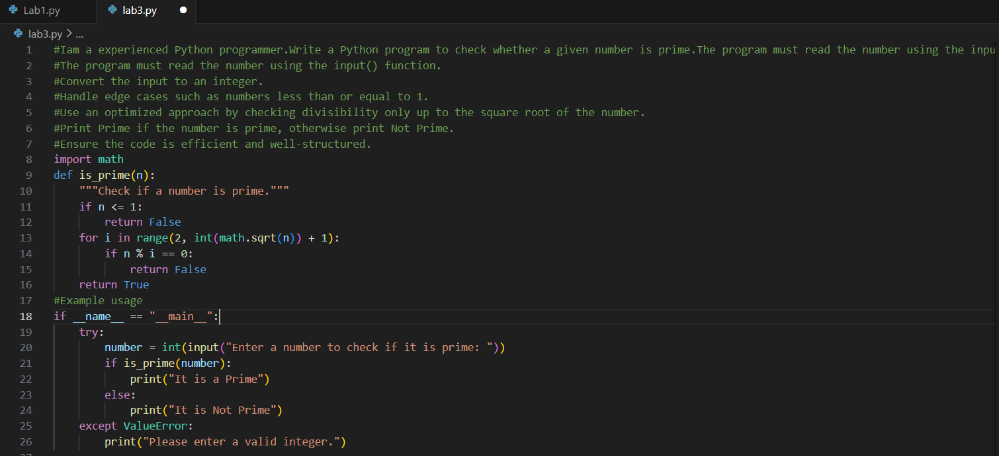
OUTPUT:
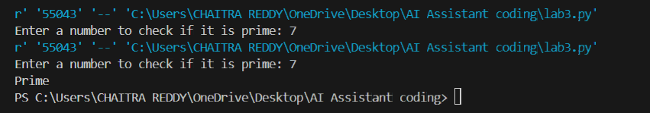
CODE:
import math
def is_prime(n):
"""Check if a number is prime."""
if n <= 1:
return False
for i in range(2, int(math.sqrt(n)) + 1):
if n % i == 0:
return False
return True
#Example usage
if __name__ == "__main__":
try:
number = int(input("Enter a number to check if it is prime: "))
if is_prime(number):
print("It is a Prime")
else:
print("It is Not Prime")
except ValueError:
print("Please enter a valid integer.")
Task: Mobile Data Usage Billing Application (1.0 Marks)
Objective:
Use Python programming and AI-assisted coding tools to create an application that simulates mobile data billing for a telecom service provider.
Instructions
- Use GitHub Copilot or Google Gemini to assist in writing the program.
- Read the following inputs from the user:
  - Data Consumed (in GB)
  - Plan Type (Prepaid / Postpaid)
  - Additional Services Used (e.g., caller tune, OTT subscription, etc.)

PROMPT: #Write a Python program to simulate a mobile data usage billing system for a telecom provider.Data Consumed (in GB),Plan Type (Prepaid / Postpaid),Additional Services Used (e.g., caller tune, OTT subscription, etc.)

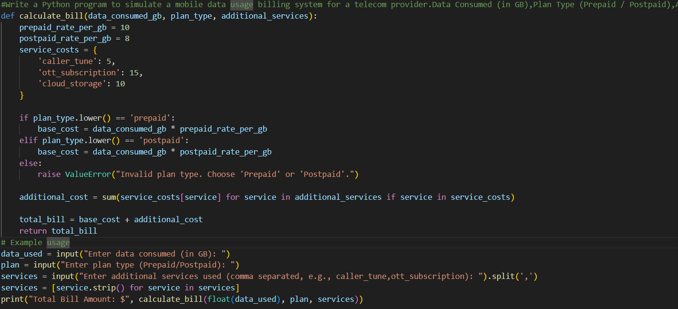

OUTPUT:

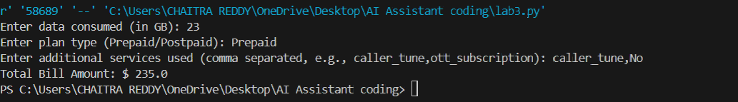

CODE:

def calculate_bill(data_consumed_gb, plan_type, additional_services):
prepaid_rate_per_gb = 10
postpaid_rate_per_gb = 8
service_costs = {
'caller_tune': 5,
'ott_subscription': 15,
'cloud_storage': 10
}

if plan_type.lower() == 'prepaid':
base_cost = data_consumed_gb * prepaid_rate_per_gb
elif plan_type.lower() == 'postpaid':
base_cost = data_consumed_gb * postpaid_rate_per_gb
else:
raise ValueError("Invalid plan type. Choose 'Prepaid' or 'Postpaid'.")

additional_cost = sum(service_costs[service] for service in additional_services if service in service_costs)

total_bill = base_cost + additional_cost
return total_bill
# Example usage
data_used = input("Enter data consumed (in GB): ")
plan = input("Enter plan type (Prepaid/Postpaid): ")
services = input("Enter additional services used (comma separated, e.g., caller_tune,ott_subscription): ").split(',')
services = [service.strip() for service in services]
print("Total Bill Amount: $", calculate_bill(float(data_used), plan, services))

- Implement billing logic to calculate:
  - DC (Data Charges) – charges based on data consumption
  - VC (Value-added Charges) – charges for additional services
  - Tax – applicable tax on the total bill

PROMPT: #Improve the previous mobile billing Python program by making the charge structure realistic.DC (Data Charges) – charges based on data consumption,VC (Value-added Charges) – charges for additional services,Tax – applicable tax on the total bill

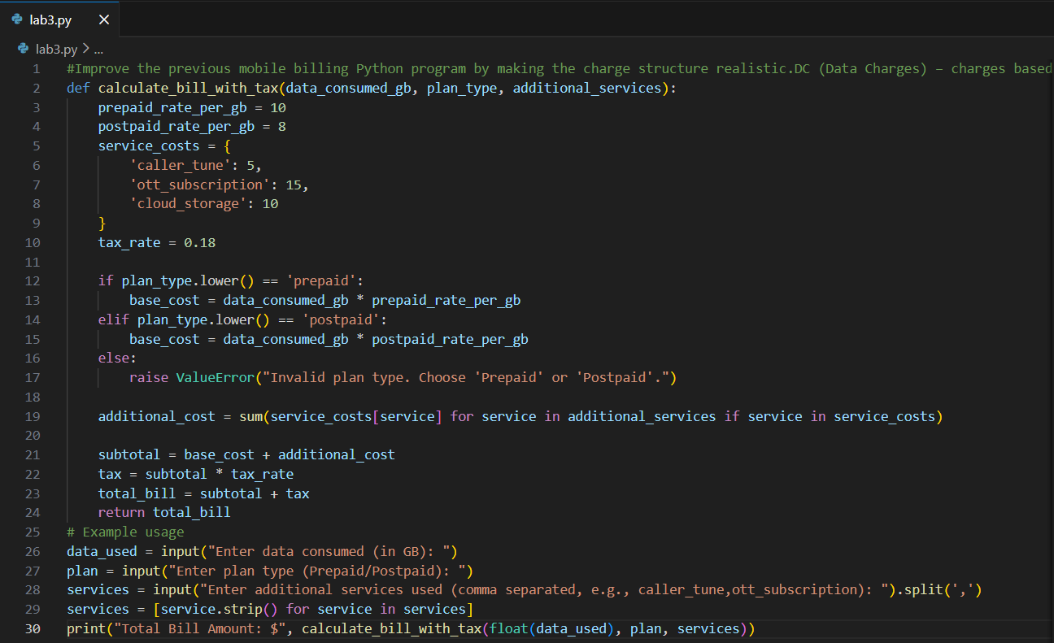

OUTPUT:

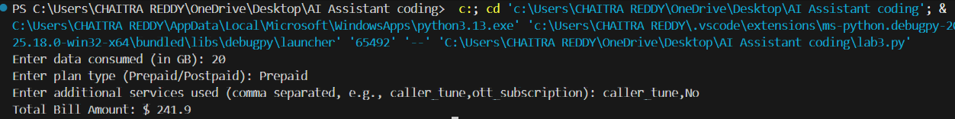

CODE:
def calculate_bill_with_tax(data_consumed_gb, plan_type, additional_services):
prepaid_rate_per_gb = 10
postpaid_rate_per_gb = 8
service_costs = {
'caller_tune': 5,
'ott_subscription': 15,
'cloud_storage': 10
}
tax_rate = 0.18

if plan_type.lower() == 'prepaid':
base_cost = data_consumed_gb * prepaid_rate_per_gb
elif plan_type.lower() == 'postpaid':
base_cost = data_consumed_gb * postpaid_rate_per_gb
else:
raise ValueError("Invalid plan type. Choose 'Prepaid' or 'Postpaid'.")

additional_cost = sum(service_costs[service] for service in additional_services if service in service_costs)

subtotal = base_cost + additional_cost
tax = subtotal * tax_rate
total_bill = subtotal + tax
return total_bill
# Example usage
data_used = input("Enter data consumed (in GB): ")
plan = input("Enter plan type (Prepaid/Postpaid): ")
services = input("Enter additional services used (comma separated, e.g., caller_tune,ott_subscription): ").split(',')
services = [service.strip() for service in services]
print("Total Bill Amount: $", calculate_bill_with_tax(float(data_used), plan, services))

4.Display an itemized bill showing:
  - Plan Type
  - Data Usage and Charges
  - Value-added Services and Charges
  - Tax
  - Total Bill Amount
PROMPT: #Modify the mobile billing program so that,All inputs are taken using the input() function,Plan type input is case-insensitive,Invalid inputs are handled gracefully,Output formatting resembles an actual mobile bill give code .

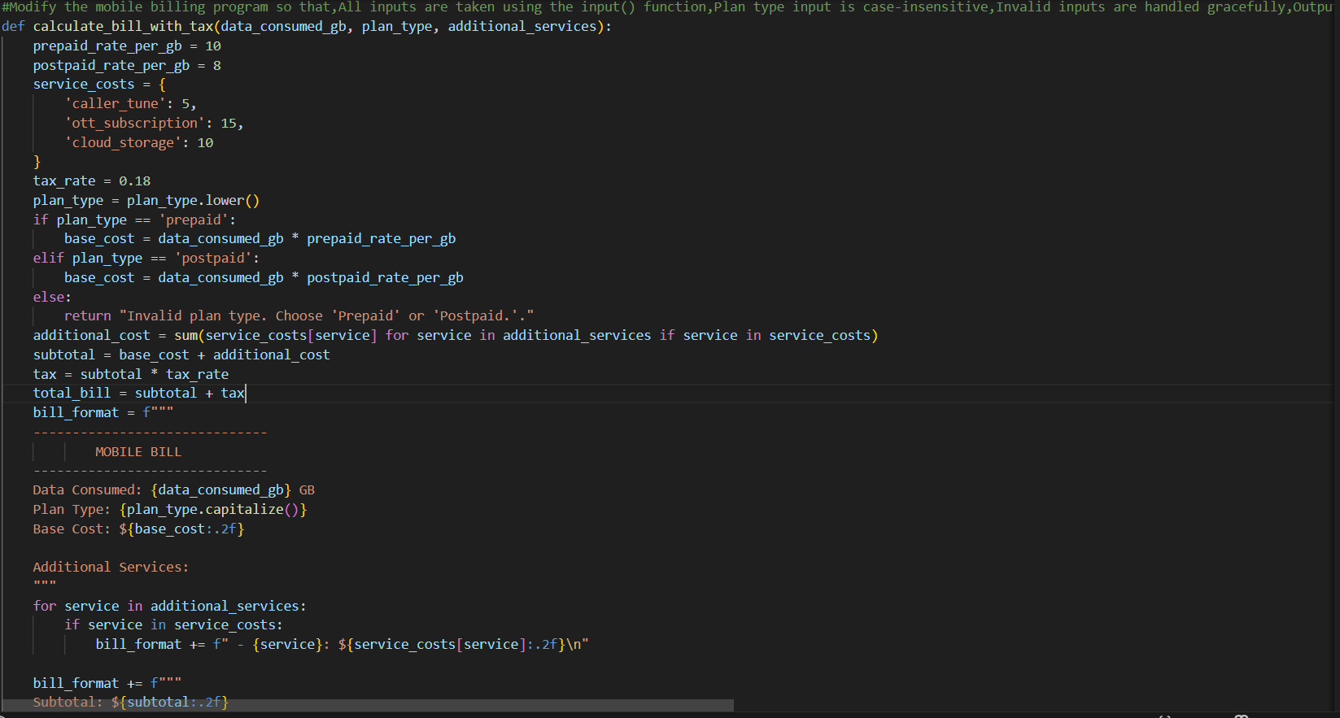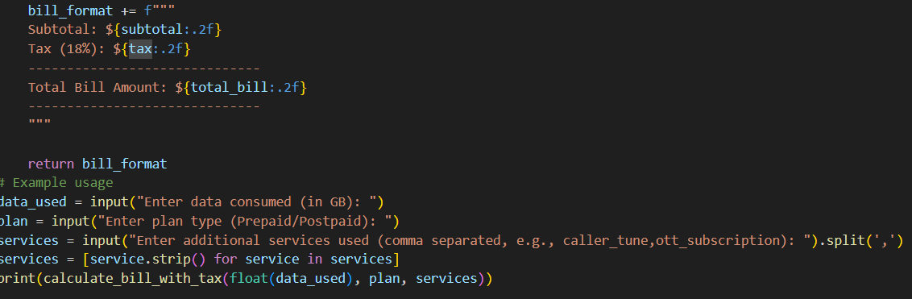

OUTPUT: 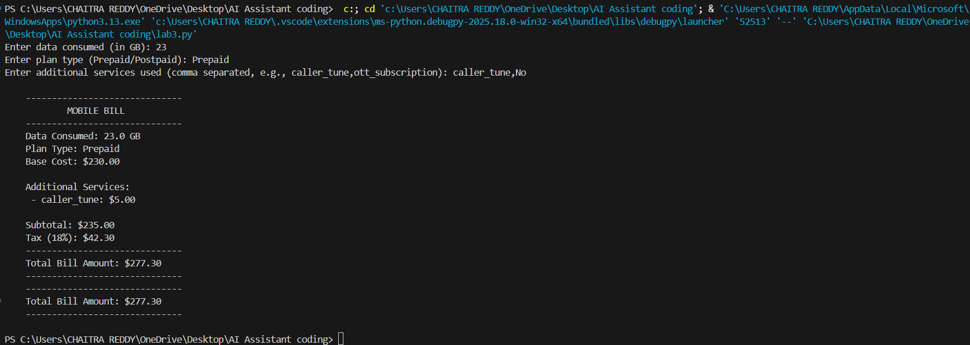

CODE:
def calculate_bill_with_tax(data_consumed_gb, plan_type, additional_services):
prepaid_rate_per_gb = 10
postpaid_rate_per_gb = 8
service_costs = {
'caller_tune': 5,
'ott_subscription': 15,
'cloud_storage': 10
}
tax_rate = 0.18
plan_type = plan_type.lower()
if plan_type == 'prepaid':
base_cost = data_consumed_gb * prepaid_rate_per_gb
elif plan_type == 'postpaid':
base_cost = data_consumed_gb * postpaid_rate_per_gb
else:
return "Invalid plan type. Choose 'Prepaid' or 'Postpaid.'."
additional_cost = sum(service_costs[service] for service in additional_services if service in service_costs)
subtotal = base_cost + additional_cost
tax = subtotal * tax_rate
total_bill = subtotal + tax
bill_format = f"""
------------------------------
MOBILE BILL
------------------------------
Data Consumed: {data_consumed_gb} GB
Plan Type: {plan_type.capitalize()}
Base Cost: ${base_cost:.2f}

Additional Services:
"""
for service in additional_services:
if service in service_costs:
bill_format += f" - {service}: ${service_costs[service]:.2f}\n"

bill_format += f"""
Subtotal: ${subtotal:.2f}
Tax (18%): ${tax:.2f}
------------------------------
Total Bill Amount: ${total_bill:.2f}
------------------------------
"""

return bill_format

Task: Develop an LPG Billing System (1.0 Marks)
Objective
Apply your Python programming skills and utilize AI-assisted coding tools to build an application that calculates the LPG bill based on specified customer inputs and billing parameters.
Instructions
- Use GitHub Copilot or Google Gemini to assist in writing and refining the program.
- Read the following user inputs:
  - Cylinder Type (Domestic 14.2 kg / Domestic 5 kg / Commercial 19 kg / Commercial 47.5 kg)
  - Number of Cylinders Booked
  - Subsidy Amount (applicable only for domestic cylinders)

PROMPT:# Generate a Python program for an LPG billing system that takes cylinder type, number of cylinders booked, and subsidy (only for domestic) as input, uses the given LPG price list and delivery charges, and calculates the total bill.

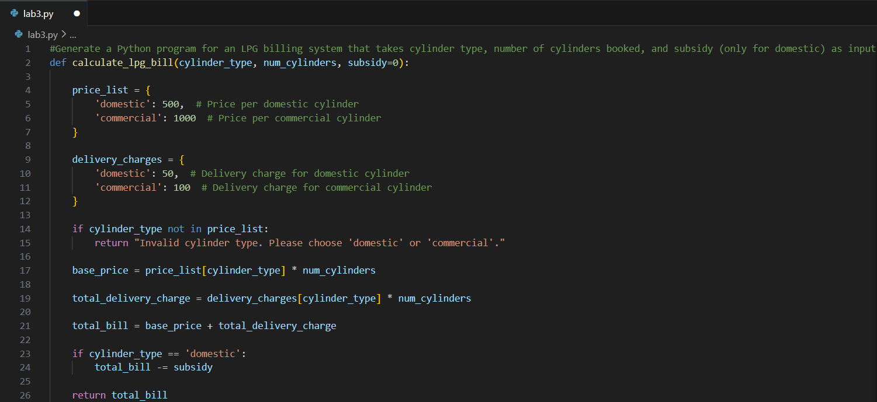
OUTPUT:
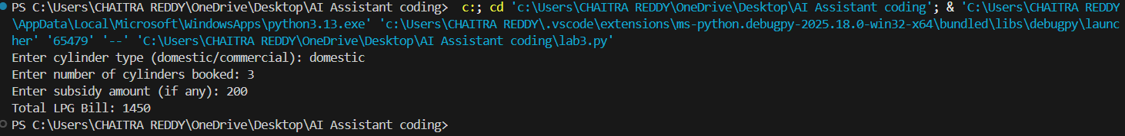
CODE:
def calculate_lpg_bill(cylinder_type, num_cylinders, subsidy=0):

price_list = {
'domestic': 500, # Price per domestic cylinder
'commercial': 1000 # Price per commercial cylinder
}

delivery_charges = {
'domestic': 50, # Delivery charge for domestic cylinder
'commercial': 100 # Delivery charge for commercial cylinder
}

if cylinder_type not in price_list:
return "Invalid cylinder type. Please choose 'domestic' or 'commercial'."

base_price = price_list[cylinder_type] * num_cylinders

total_delivery_charge = delivery_charges[cylinder_type] * num_cylinders

total_bill = base_price + total_delivery_charge

if cylinder_type == 'domestic':
total_bill -= subsidy

return total_bill
# Example usage
cylinder_type = input("Enter cylinder type (domestic/commercial): ").strip().lower()
num_cylinders = int(input("Enter number of cylinders booked: "))
subsidy = 0
if cylinder_type == 'domestic':
subsidy = int(input("Enter subsidy amount (if any): "))
total_bill = calculate_lpg_bill(cylinder_type, num_cylinders, subsidy)
print(f"Total LPG Bill: {total_bill}")

- Refer to the given LPG Price List to determine the price per cylinder:
  - Domestic LPG (14.2 kg) → ₹905.00
  - Domestic LPG (5 kg) → ₹335.50
  - Commercial LPG (19 kg) → ₹1,886.50
  - Commercial LPG (47.5 kg) → ₹4,712.00
  - Delivery Charges (₹10 to ₹50)

PROMPT:
- Implement the billing formula:
Bill Amount = (Price per Cylinder × Quantity) - Subsidy (if applicable) + Delivery Charges
PROMPT:
- Calculate and display an itemized bill including:
- Cylinder Type
- Number of Cylinders
- Base Amount
- Subsidy
- Delivery Charges
- Total Bill Amount

Deliverables
- A report containing:
  - AI prompts used to generate the program
  - AI-generated Python code
  - Line-by-line explanation of the code

